**NAME : HARUL NARTH RAJ A/L SELWAR RAJU**

**MATRIC NUMBER: BI19110105**

**COURSE : KK14203 OBJECT ORIENTED PROGRAMMING (SECTION 1)**

**LECTURER : DR MOHD SHAMRIE SAININ**

**1. Add Menu Bar at the top with menu ‘Load Data’ to read from file and view in the output textrea. Menu ‘Exit’ to show ‘showConfirmDialog’ and exit the application if user select ‘yes’ in the dialog.**

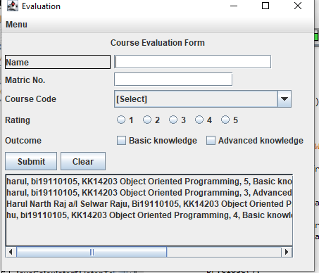

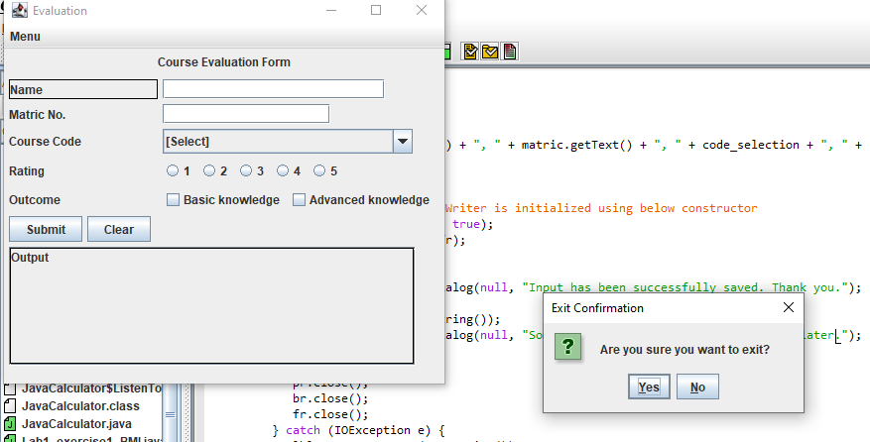

**2. Input validation from all input to check if user empty field or selections when user click ‘Submit’ button.**

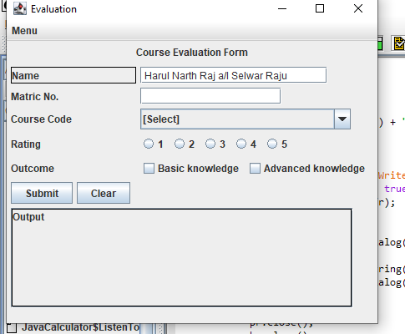

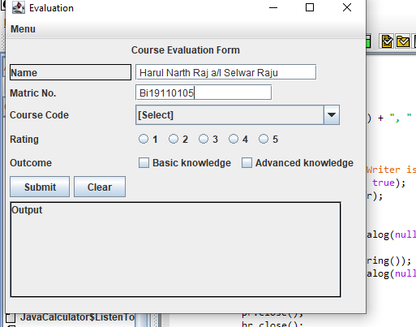

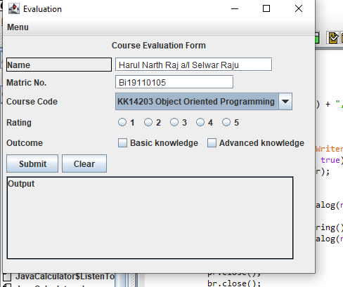

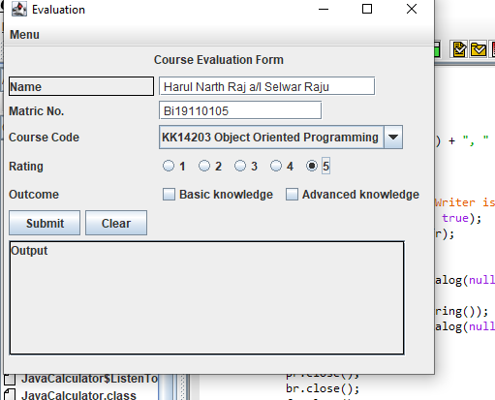

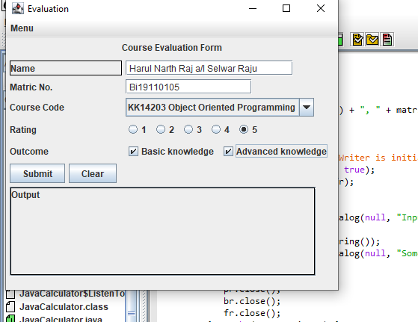

**3. Save (add) the data into a text file with dialog notification (e.g. showMessageDialog) whether input is successfully saved.**

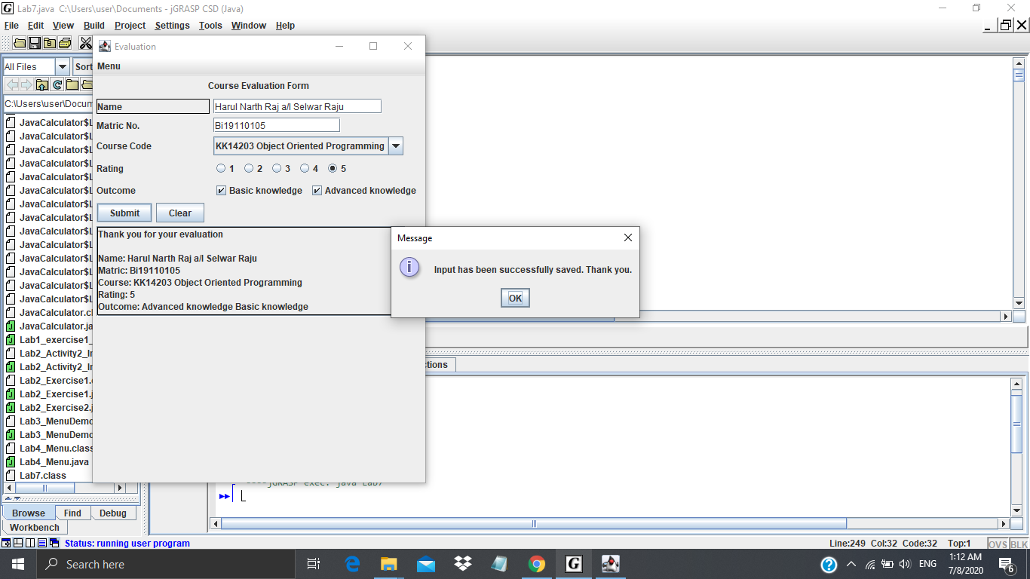

**4. Implement at least ONE (1) exception handling (e.g. file IO and dealing with empty input field.**

